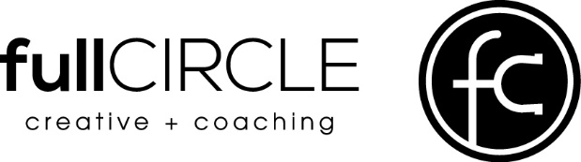
Kimberly Gratny
515.229.0429
kim@seekfullcircle.com
seekfullcircle.com

Release + Liability Waiver Agreement

I, (“Participant”), acknowledge that I have voluntarily applied to participate in the following activities with fullCIRCLE creative + coaching, LLC.

(Description of activities Participant will engage in)
I AM AWARE THAT THE ACTIVITIES ARE ACTIVITIES IN WHICH I COULD BE INJURED WHILE PARTICIPATING. I AM ALSO VOLUNTARILY PARTICIPATING IN THESE ACTIVITIES WITH KNOWLEDGE OF THE DANGER INVOLVED, AND AGREE TO ASSUME ANY AND ALL RISKS OF BODILY INJURY OR PROPERTY DAMAGE, WHETHER THOSE RISKS ARE KNOWN OR UNKNOWN.

I verify this statement by placing my initials here:

As consideration for being permitted by fullCIRCLE creative + coaching, LLC, to participate in these activities and use the premises and facilities, I forever release fullCIRCLE creative + coaching, LLC, and any of their trainers, facilitators or coaches, from any and all actions, claims or demands that I have in the future for injury or property damage, related to (i) my participation in these activities, (ii) the negligence or other acts, whether directly connected to these activities or not, and however caused, or (iii) the condition of the premises where these activities occur, whether or not I am then participating in the activities.

I HAVE CAREULLY READ THIS AGREEMENT AND FULLY UNDERSTAND ITS CONTENTS. I AM AWARE THAT THIS IS A RELEASE OF LIABILITY AND A CONTRACT BETWEEN MYSELF AND fullCIRCLE creative + coaching, LLC AND SIGN IT OF MY OWN FREE WILL.

Executed at 1716 105th St. Earlham, IA 50072 on (date)

PARTICIPANT/RELEASOR

Printed Name

Signature

Mailing Address

